DOKUMENTASI
Guru sedang melihat keadaan kelas | Melakukan pembelajaran di kelas TGT dan STAD
Google form untuk soal kuis pada kelas STAD | 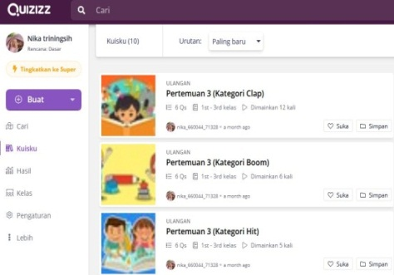  Quizizz untuk soal turnamen pada kelas TGT
Keadaan group belajar kelas STAD | Keadaan group belajar kelas TGT
Keadaan group kelompok peserta didik | 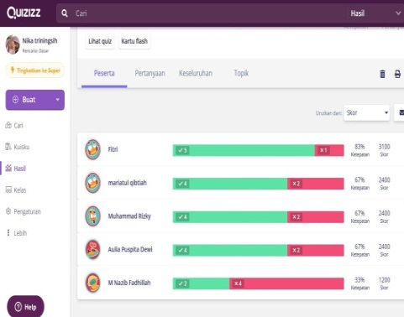  Hasil soal turnamen kelas TGT

UJI VALIDITAS SOAL SISTEM EKSKRESI
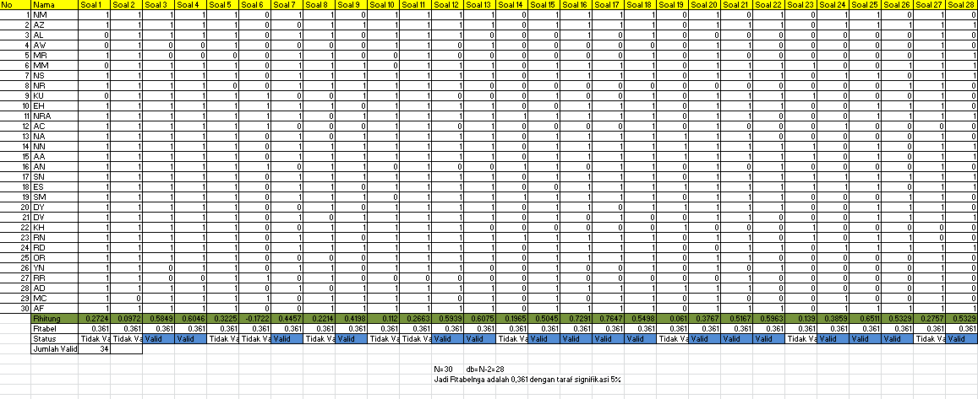
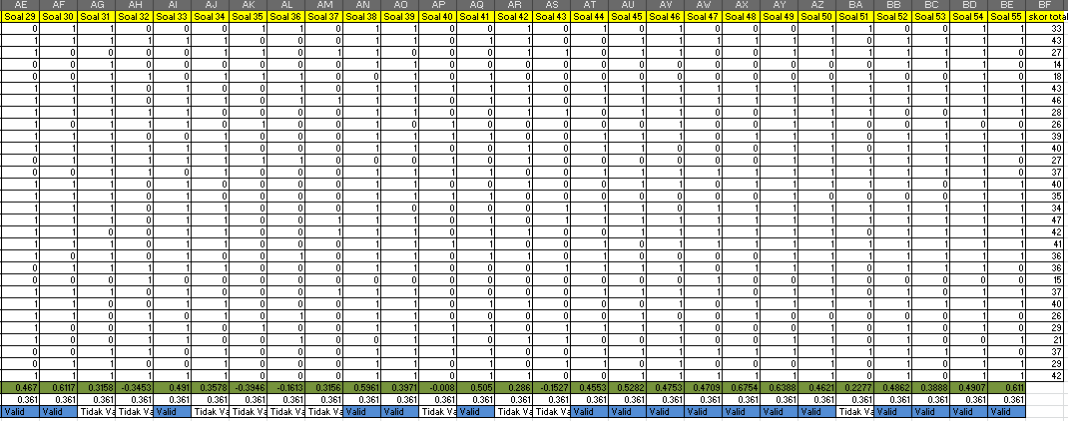

UJI RELIABILITAS SOAL
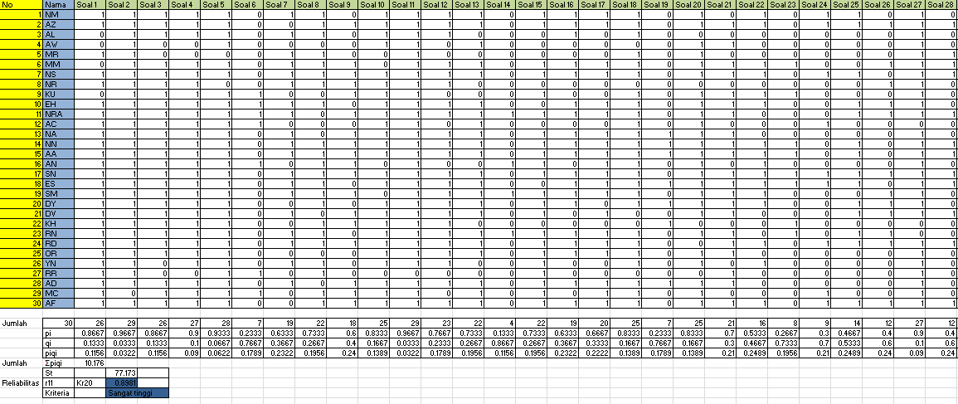
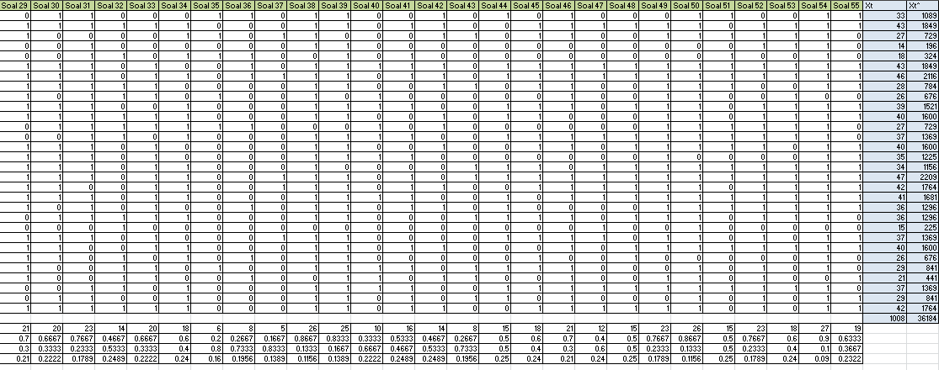

UJI TINGKAT KESUKARAN BUTIR SOAL
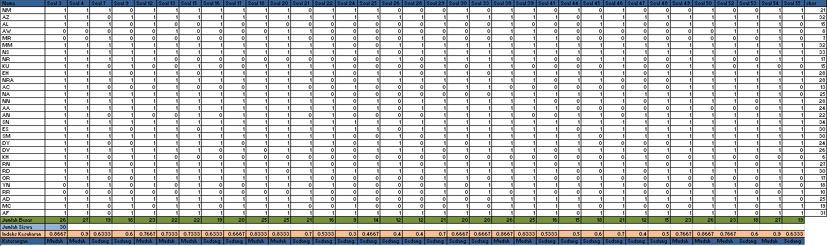

UJI DAYA BEDA BUTIR SOAL
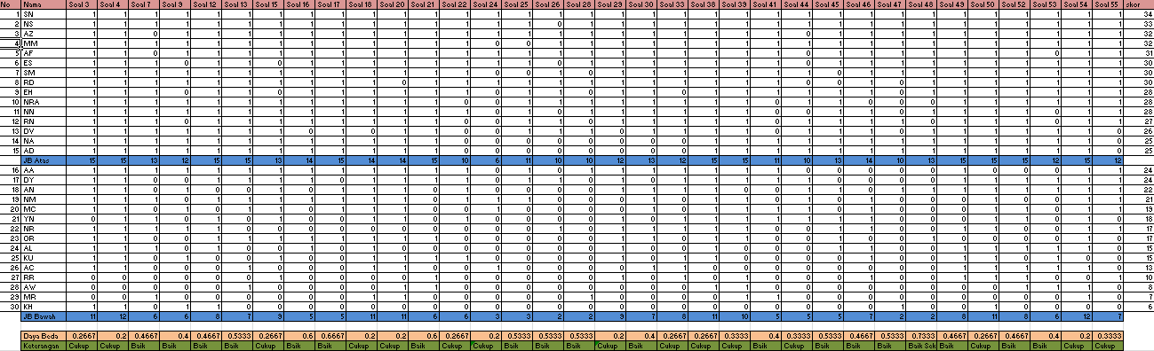

UJI VALIDITAS ANGKET MINAT
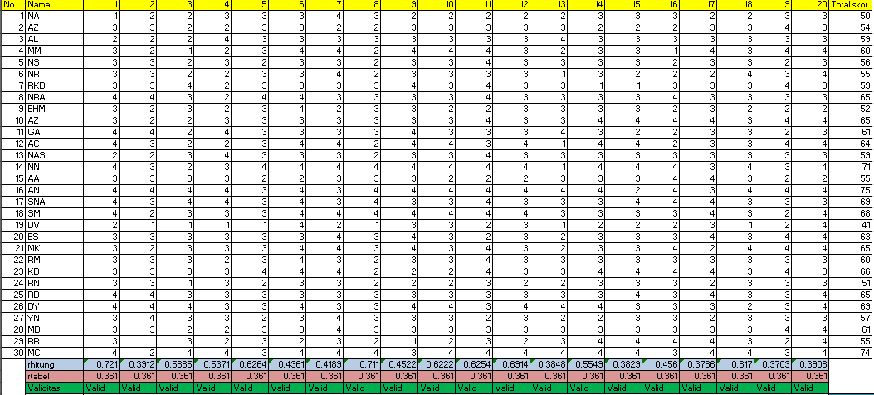

UJI RELIABILITAS ANGKET MINAT
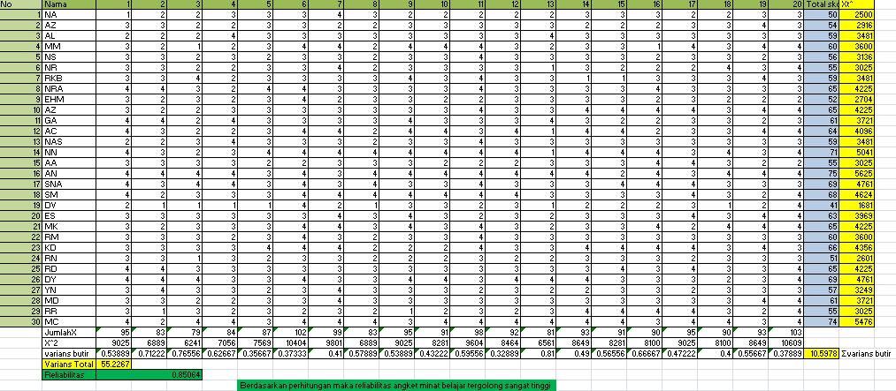

SAMPEL JAWABAN PESERTA DIDIK
Kelas TGT
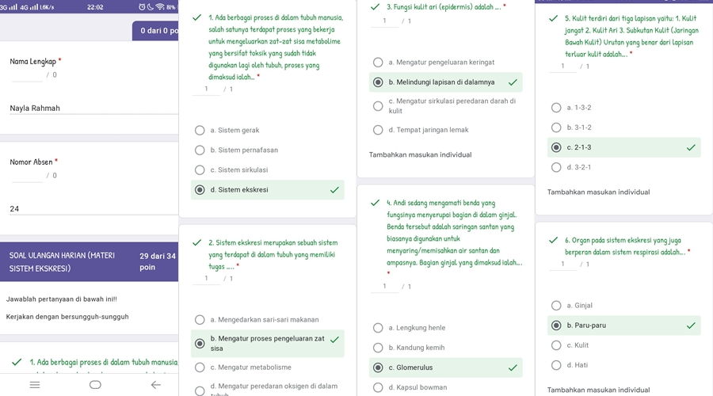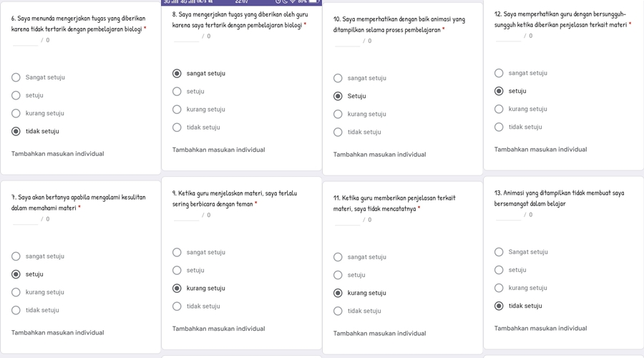
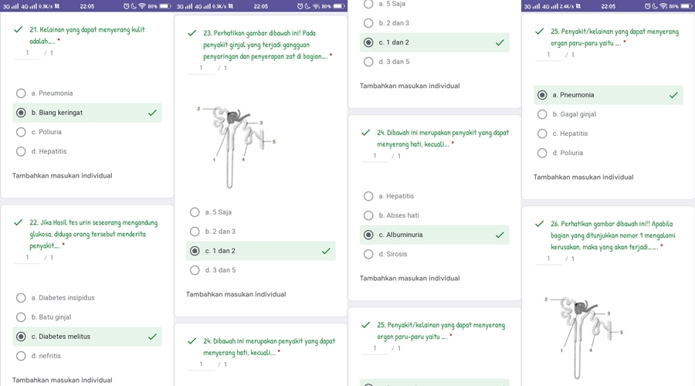
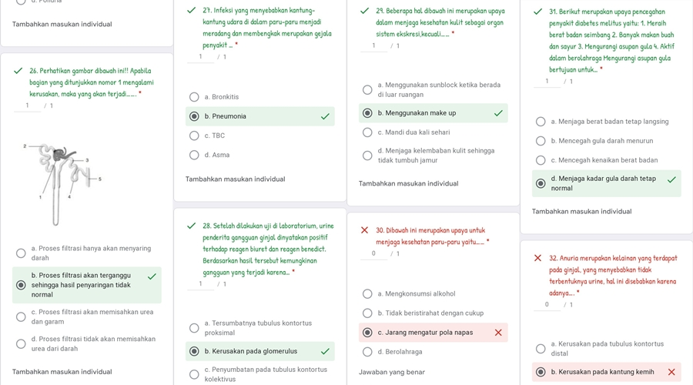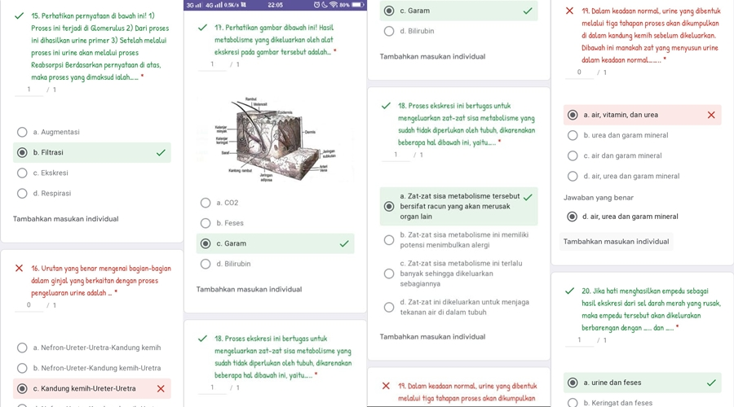

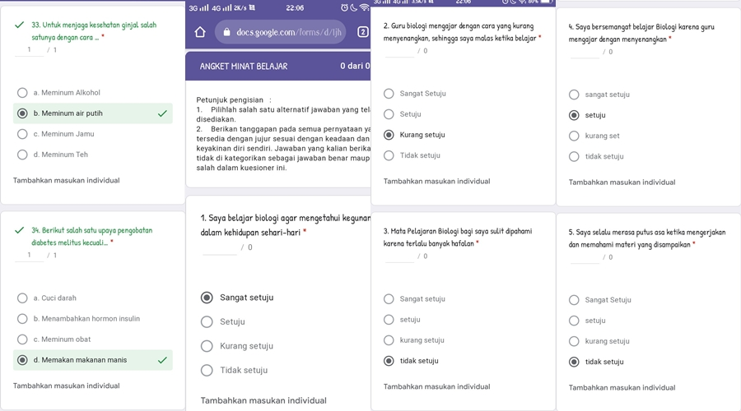
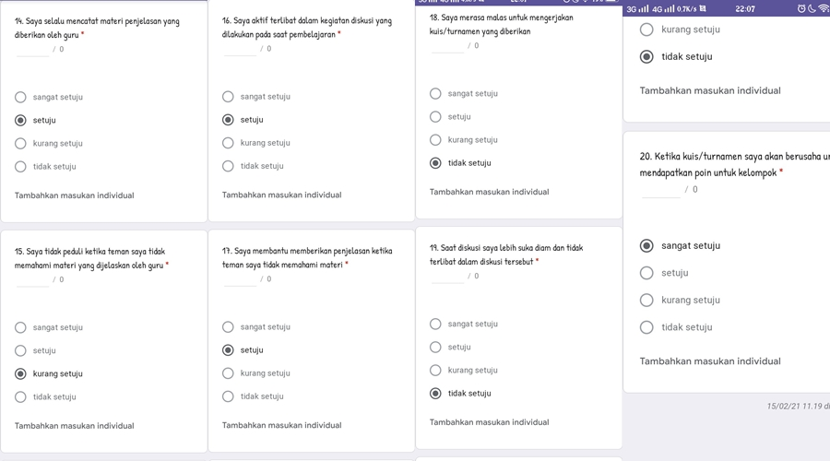

Kelas STAD
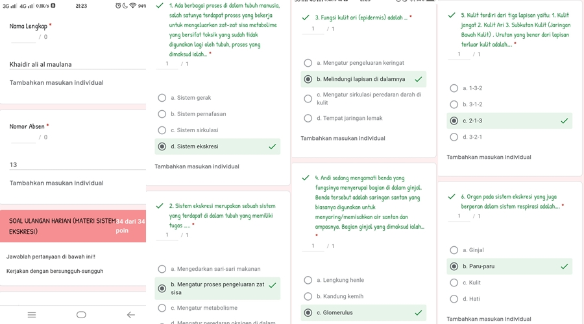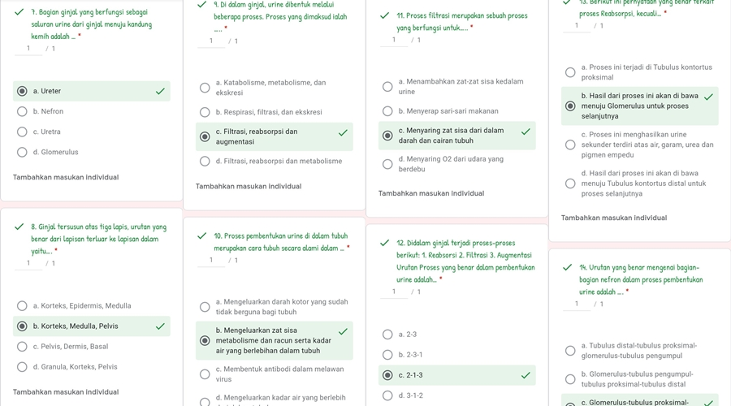

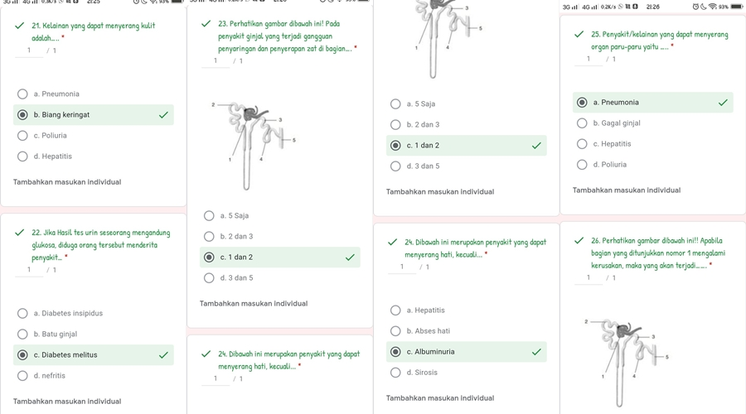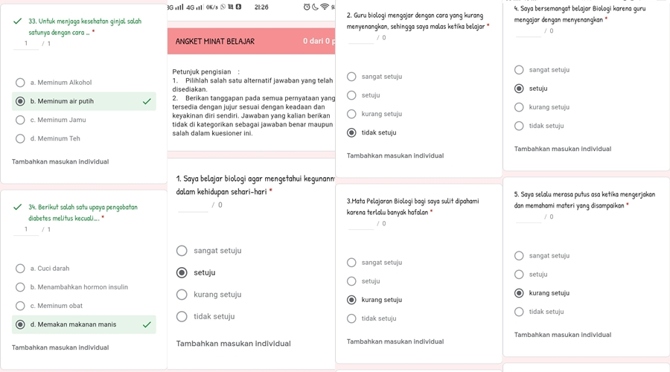
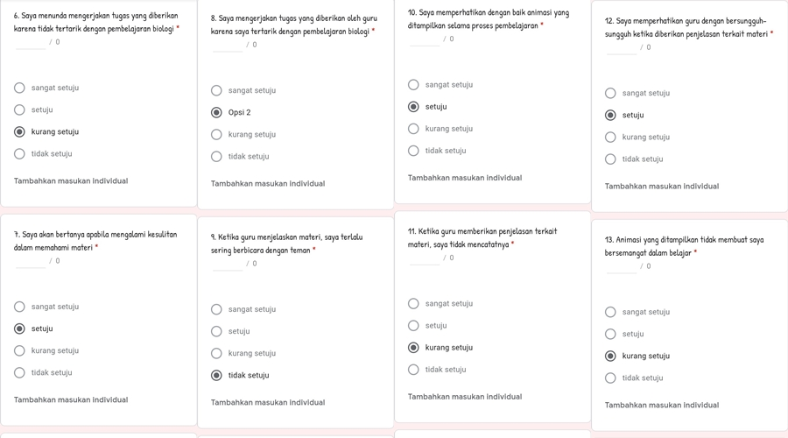

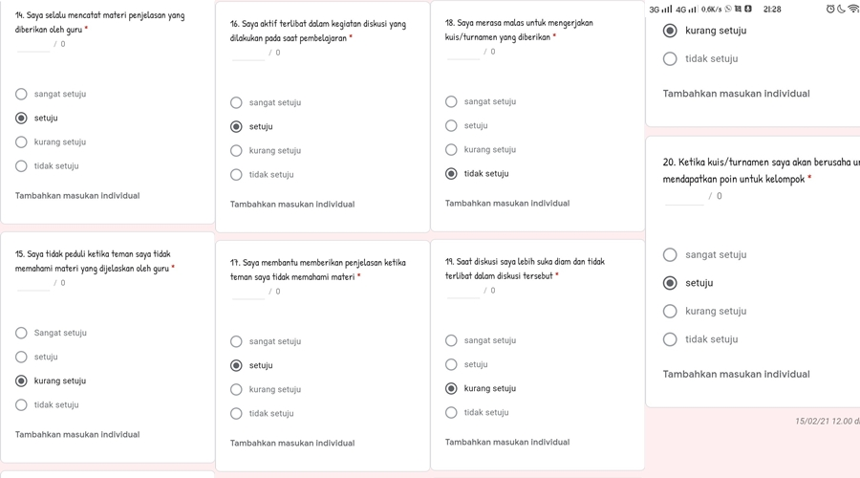

PERHITUNGAN RATA-RATA ANGKET MINAT KELAS TGT
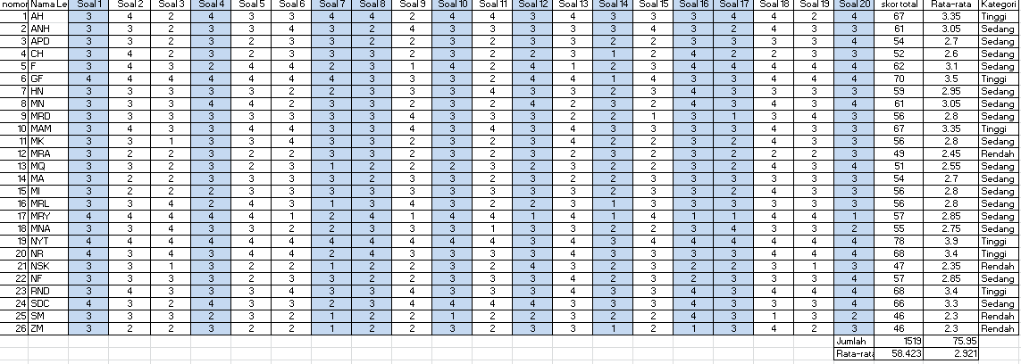
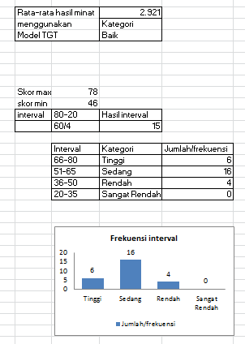

PERHITUNGAN PERSENTASE ANGKET MINAT KELAS TGT
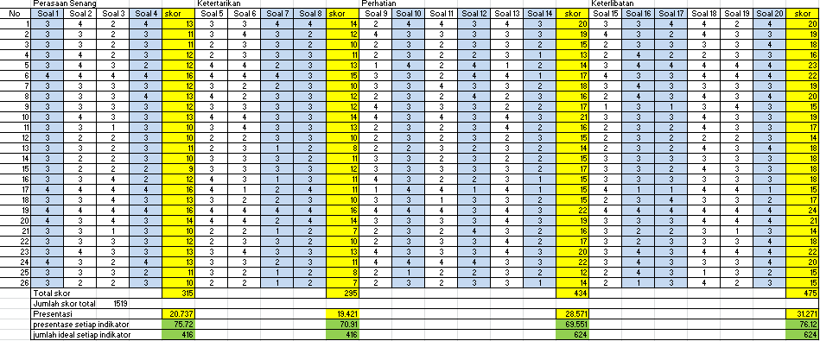
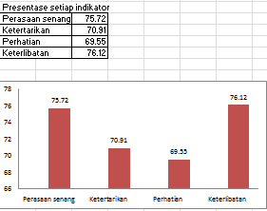

PERHITUNGAN PERSENTASE HASIL OBSERVASI MINAT KELAS TGT
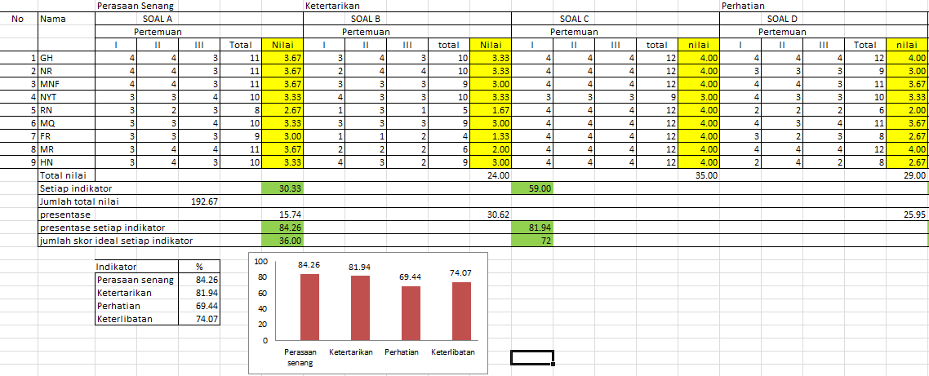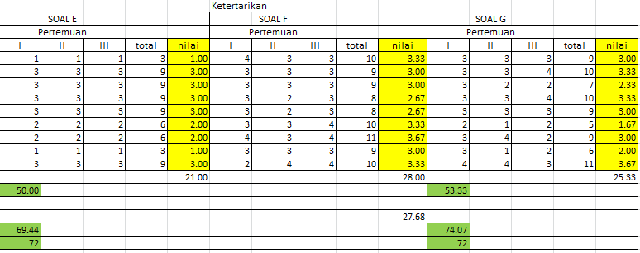

PERHITUNGAN RATA-RATA MINAT KELAS STAD
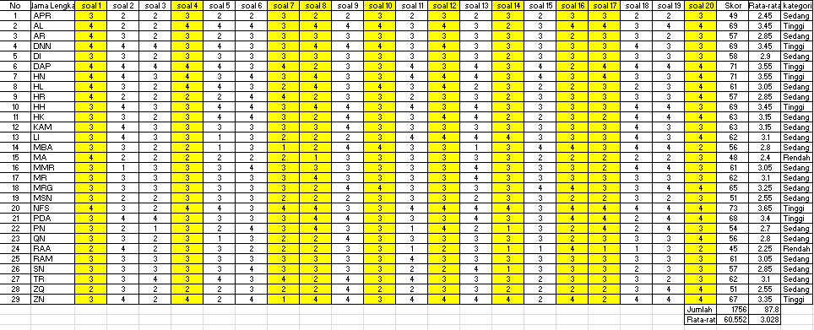
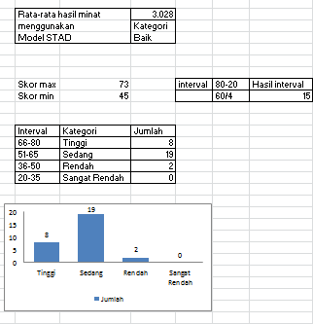

PERHITUNGAN PERSENTASE ANGKET MINAT KELAS STAD
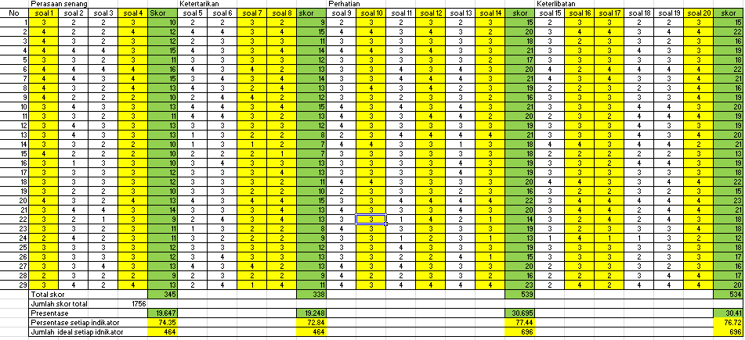
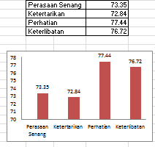

PERHITUNGAN PERSENTASE HASIL OBSERVASI MINAT KELAS STAD
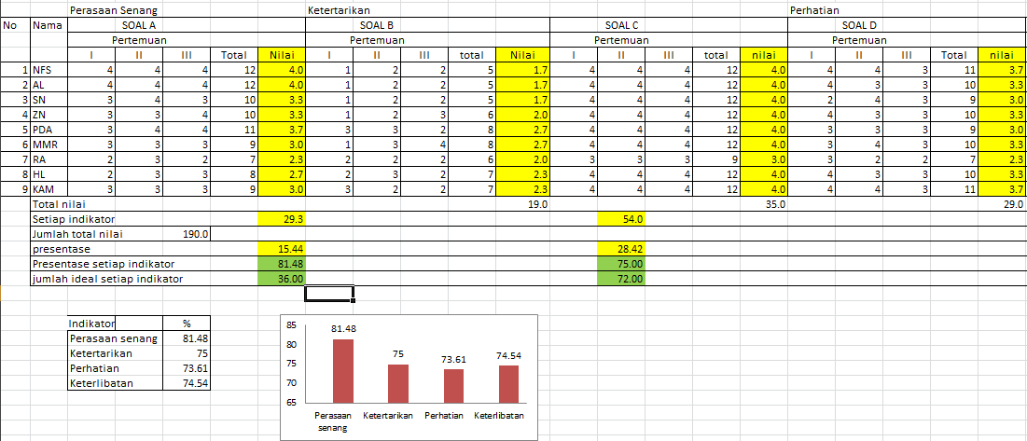
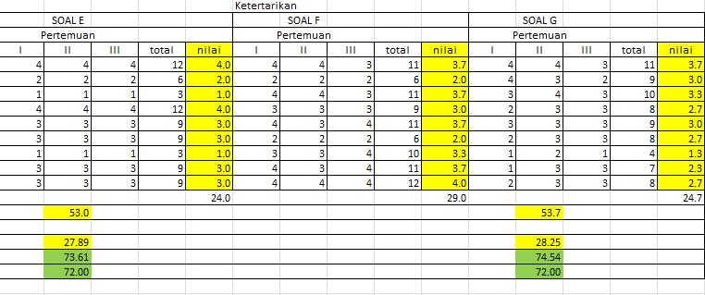

PERHITUNGAN UJI NORMALITAS HASIL ANGKET MINAT KELAS TGT DAN STAD

Tests of Normality
 | Kelas | Kolmogorov-Smirnovª |  |  | Shapiro-Wilk
 |  | Statistic | df | Sig. | Statistic | df | Sig.
MinatBelajar | 8a | .147 | 26 | .156 | .960 | 26 | .386
 | 8c | .110 | 29 | .200* | .968 | 29 | .510
*. This is a lower bound of the true significance.
a. Lilliefors Significance Correction

PERHITUNGAN UJI HOMOGENITAS HASIL ANGKET MINAT KELAS TGT DAN STAD
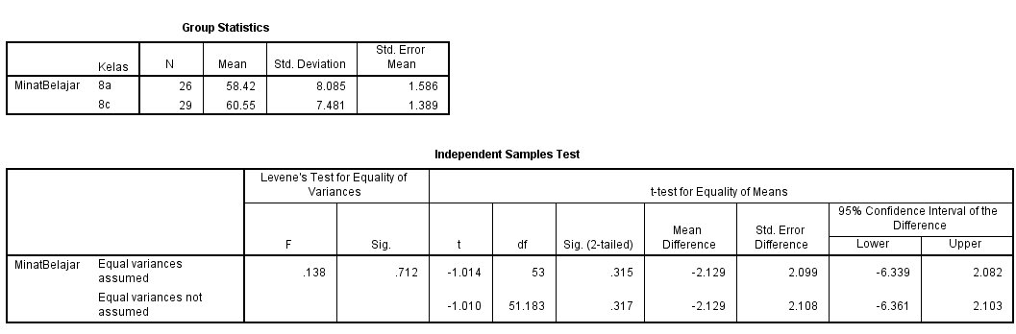

PERHITUNGAN UJI HIPOTESIS HASIL ANGKET MINAT KELAS TGT DAN STAD

Independent Samples Test
 |  | Levene's Test for Equality of Variances |  | t-test for Equality of Means
 |  | F | Sig. | t | df | Sig. (2-tailed) | Mean Difference | Std. Error Difference | 95% Confidence Interval of the Difference
 |  |  |  |  |  |  |  |  | Lower | Upper
MinatBelajar | Equal variances assumed | .138 | .712 | -1.014 | 53 | .315 | -2.129 | 2.099 | -6.339 | 2.082
 | Equal variances not assumed |  |  | -1.010 | 51.183 | .317 | -2.129 | 2.108 | -6.361 | 2.103

HASIL PRETEST KELAS TGT
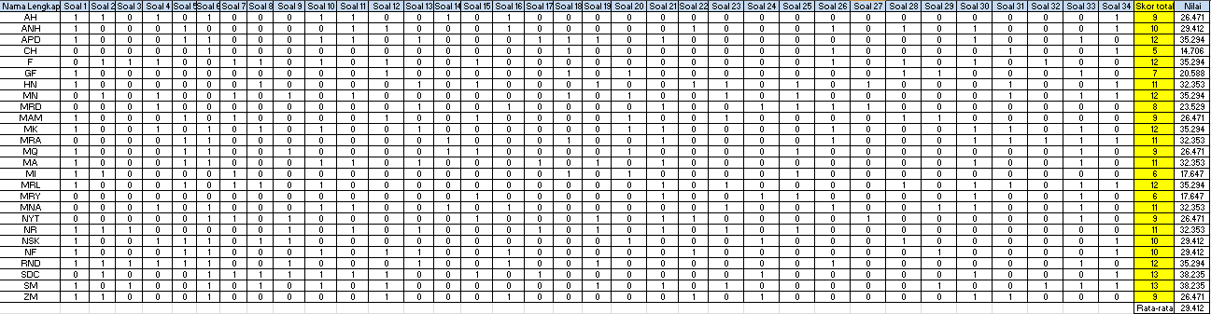

HASIL POSTTEST KELAS TGT
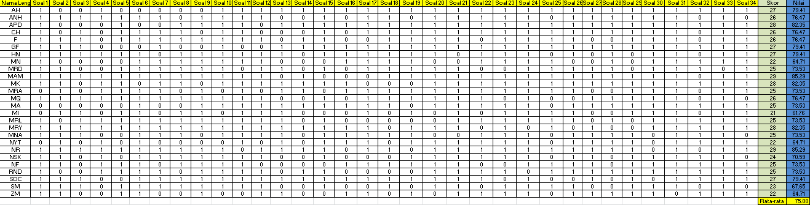

HASIL PRETEST KELAS STAD
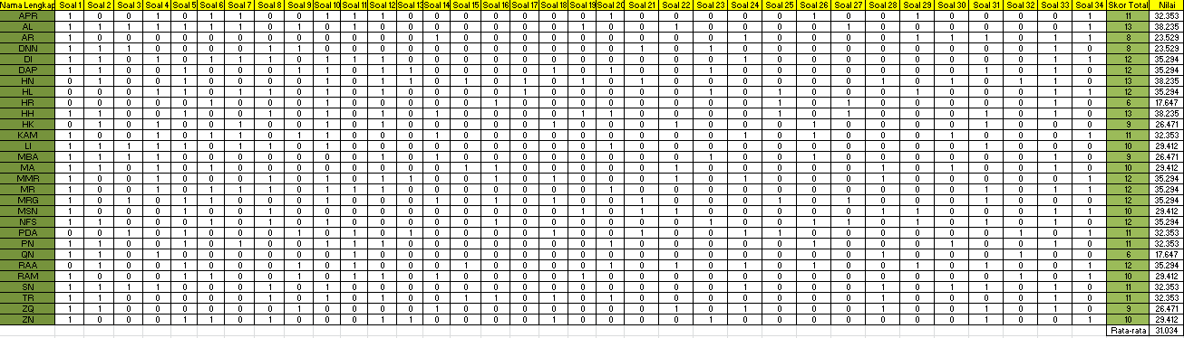

HASIL POSTTEST KELAS STAD
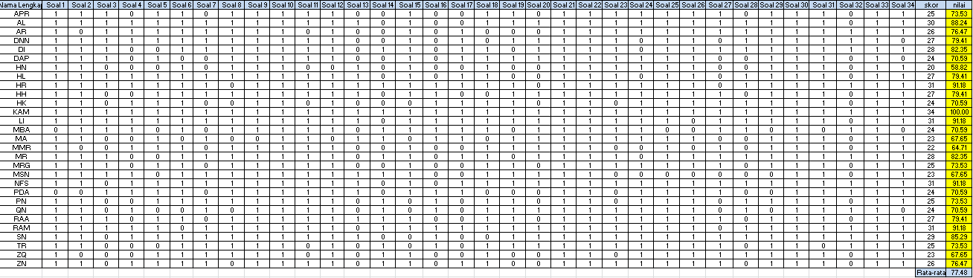

PERHITUNGAN N-GAIN KELAS TGT DAN STAD

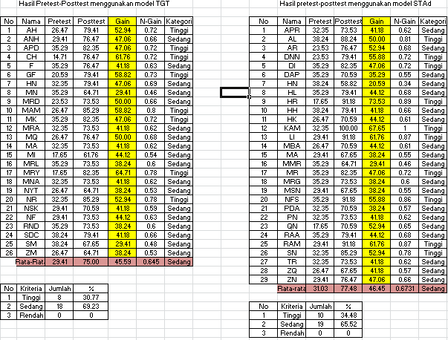

PERHITUNGAN UJI NORMALITAS HASIL NILAIGAIN HASIL BELAJAR KELAS TGT DAN STAD

Tests of Normality
 | Model | Kolmogorov-Smirnovª |  |  | Shapiro-Wilk
 |  | Statistic | df | Sig. | Statistic | df | Sig.
HasilBelajar | ModelTGT | .151 | 26 | .132 | .952 | 26 | .254
 | ModelSTAD | .135 | 29 | .192 | .964 | 29 | .421
a. Lilliefors Significance Correction

PERHITUNGAN UJI HOMOGENITAS HASIL NILAIGAIN HASIL BELAJAR KELAS TGT DAN STAD

Test of Homogeneity of Variances
HasilBelajar
Levene Statistic | df1 | df2 | Sig.
.712 | 1 | 53 | .403

PERHITUNGAN UJI HIPOTESIS HASIL NILAIGAIN HASIL BELAJAR KELAS TGT DAN STAD

Independent Samples Test
 |  | Levene's Test for Equality of Variances |  | t-test for Equality of Means
 |  | F | Sig. | t | df | Sig. (2-tailed) | Mean Difference | Std. Error Difference | 95% Confidence Interval of the Difference
 |  |  |  |  |  |  |  |  | Lower | Upper
HasilBelajar | Equal variances assumed | .712 | .403 | -.314 | 53 | .755 | -.862 | 2.745 | -6.368 | 4.645
 | Equal variances not assumed |  |  | -.318 | 52.368 | .752 | -.862 | 2.712 | -6.303 | 4.580

