Lampiran 1
Abnormal Return Sebelum Pandemi Covid-19 (2019)
Kode Emiten | PERIODE PENGAMATAN
 | T-3 | T-2 | T-1 | T0 | T+1 | T+2 | T+3
 | 26-03-20 | 27-03-20 | 30-03-20 | 31-03-20 | 01-04-20 | 02-04-20 | 03-04-20
ADRO | 0,13791 | 0,02852 | -0,06304 | 0,07289 | 0,03292 | 0,02222 | 0,06031
AKRA | 0,10747 | 0,09023 | -0,06194 | 0,03466 | -0,01677 | 0,00084 | 0,02946
ANTM | 0,15013 | 0,11305 | -0,05359 | 0,04894 | -0,02383 | 0,04397 | 0,03383
BRPT | 0,19995 | 0,14238 | -0,02749 | 0,21310 | 0,03236 | 0,11886 | 0,20959
BTPS | 0,07885 | 0,08232 | -0,06637 | -0,06277 | -0,06505 | -0,02972 | -0,05687
CPIN | 0,10099 | 0,16804 | -0,06544 | 0,08037 | -0,03669 | 0,03124 | -0,00641
EXCL | 0,25524 | 0,02975 | 0,00702 | 0,11813 | -0,01798 | 0,05830 | 0,05580
ICBP | 0,14757 | 0,05299 | -0,02959 | 0,06258 | -0,00434 | 0,00792 | -0,01662
INCO | 0,18304 | 0,06367 | 0,01547 | 0,07477 | -0,05472 | 0,09414 | 0,05524
INDF | 0,18637 | 0,14128 | -0,06298 | 0,00320 | 0,00320 | 0,07407 | -0,02621
INKP | 0,16999 | 0,14140 | -0,07375 | 0,02930 | -0,00670 | 0,04830 | 0,06706
INTP | 0,20200 | 0,08055 | -0,06535 | 0,00997 | -0,02207 | -0,02481 | 0,01239
JPFA | 0,14412 | 0,07919 | -0,06458 | 0,01536 | -0,02685 | 0,05364 | 0,00991
KAEF | 0,25601 | -0,03245 | -0,06199 | 0,13047 | -0,01308 | 0,01768 | 0,00985
KLBF | 0,10344 | 0,06834 | 0,03983 | 0,15350 | -0,02399 | 0,10818 | -0,02206
MDKA | 0,12259 | 0,01268 | -0,02920 | -0,01131 | 0,03264 | 0,01762 | 0,03658
MIKA | 0,09884 | -0,02820 | 0,03616 | 0,13803 | -0,06631 | 0,00346 | 0,03346
MNCN | 0,10311 | 0,03151 | -0,03557 | 0,04333 | -0,00242 | 0,11422 | 0,00311
PGAS | 0,13342 | 0,12710 | -0,03002 | 0,07109 | -0,04216 | 0,09789 | 0,00945
PTBA | 0,12967 | 0,01108 | -0,06745 | 0,14855 | -0,05845 | -0,00858 | 0,04059
PTPP | 0,09998 | 0,11322 | -0,05893 | 0,01862 | -0,05419 | 0,02886 | 0,09516
PWON | 0,16321 | 0,08391 | -0,05938 | -0,00633 | 0,01948 | 0,05777 | 0,05527
SCMA | 0,05227 | 0,02332 | -0,06204 | 0,08724 | -0,02249 | 0,05630 | -0,00297
SMGR | 0,11447 | 0,17706 | -0,06470 | 0,03120 | 0,01410 | -0,02171 | 0,03093
TKIM | 0,12742 | 0,03123 | -0,06235 | 0,00492 | -0,02015 | 0,08474 | 0,15096
TLKM | 0,14107 | 0,04058 | 0,01985 | 0,01004 | -0,01532 | 0,01335 | 0,02603
TPIA | 0,01081 | -0,06426 | -0,03331 | -0,02538 | 0,00240 | 0,09288 | 0,19891
UNTR | 0,07771 | 0,03419 | -0,06678 | 0,17415 | -0,01370 | 0,01911 | 0,01736
UNVR | 0,20427 | 0,01413 | -0,04471 | 0,13884 | -0,00335 | 0,02093 | -0,00686
WIKA | 0,11752 | 0,10034 | -0,06101 | 0,02546 | 0,00717 | 0,04310 | 0,05919

Lampiran 2
Abnormal Return Saat Pandemic Covid-19 (2020)
Kode Emiten | PERIODE PENGAMATAN
 | T-3 | T-2 | T-1 | T0 | T+1 | T+2 | T+3
 | 26/03/21 | 29/03/21 | 30/03/21 | 31/03/21 | 04/04/21 | 05/04/21 | 06/04/21
ADRO | 0,01161 | -0,01230 | -0,02490 | 0,00000 | 0,00341 | -0,00737 | 0,03339
AKRA | 0,03430 | -0,03254 | -0,02446 | 0,00940 | -0,00562 | -0,00849 | 0,01851
ANTM | 0,10388 | -0,06996 | -0,02212 | 0,01810 | -0,01524 | -0,05216 | 0,09164
BRPT | -0,03000 | 0,06349 | -0,01493 | -0,03030 | -0,01985 | -0,08801 | 0,09600
BTPS | 0,03487 | -0,01630 | 0,00000 | -0,03867 | 0,00687 | -0,00855 | -0,00287
CPIN | 0,00213 | 0,04364 | 0,01045 | -0,03448 | -0,00509 | 0,01792 | -0,00704
EXCL | 0,00375 | -0,00476 | -0,01914 | 0,01951 | -0,00103 | -0,00957 | 0,04348
ICBP | 0,01765 | 0,01374 | -0,01626 | 0,01377 | -0,02628 | -0,00279 | -0,01120
INCO | 0,07088 | -0,02991 | -0,00881 | -0,02667 | 0,02031 | -0,01116 | 0,05192
INDF | 0,01937 | 0,00755 | -0,01509 | -0,01509 | 0,01937 | -0,01132 | 0,01509
INKP | 0,00154 | -0,01279 | -0,04968 | -0,05000 | 0,01400 | -0,01412 | 0,01671
INTP | -0,00973 | -0,00574 | -0,03077 | -0,02976 | 0,02036 | -0,02200 | -0,00409
JPFA | 0,01093 | 0,03937 | 0,01515 | -0,04478 | 0,05743 | 0,00980 | -0,02427
KAEF | 0,04407 | -0,03460 | -0,02867 | -0,05535 | 0,02431 | -0,00760 | -0,01533
KLBF | -0,00701 | -0,02532 | 0,00000 | 0,01948 | -0,01346 | 0,00000 | 0,00323
MDKA | 0,02246 | -0,01288 | -0,04348 | -0,02273 | 0,03789 | 0,00446 | 0,02667
MIKA | -0,00892 | -0,01091 | -0,02574 | -0,00755 | -0,01311 | 0,00385 | -0,02299
MNCN | 0,02116 | -0,01923 | -0,03431 | -0,03046 | -0,01918 | -0,00532 | 0,00535
PGAS | 0,02316 | 0,01103 | -0,03636 | -0,00755 | -0,00325 | -0,02662 | 0,01172
PTBA | 0,00074 | -0,00741 | -0,01866 | -0,00380 | 0,00847 | -0,04151 | -0,00787
PTPP | 0,00439 | -0,01338 | -0,06780 | -0,00364 | -0,00209 | -0,06909 | 0,04297
PWON | 0,04213 | -0,02655 | -0,00909 | -0,00917 | -0,00417 | -0,00926 | 0,01869
SCMA | 0,04188 | 0,04348 | -0,03333 | -0,02299 | -0,00358 | 0,01471 | -0,00290
SMGR | -0,02016 | 0,00677 | -0,02466 | -0,04138 | -0,00242 | -0,01199 | 0,00728
TKIM | -0,00869 | 0,00210 | -0,06289 | -0,06711 | 0,03177 | -0,00693 | 0,04651
TLKM | 0,02129 | -0,02292 | -0,00880 | 0,01183 | -0,01094 | -0,00295 | -0,00296
TPIA | 0,01276 | 0,00688 | 0,02733 | -0,01330 | -0,00356 | -0,01124 | 0,00455
UNTR | 0,02599 | -0,00457 | -0,01376 | 0,02907 | 0,00249 | 0,00113 | 0,00563
UNVR | -0,00629 | 0,01894 | -0,02602 | 0,00382 | 0,00883 | -0,02264 | 0,00000
WIKA | 0,01160 | -0,02167 | -0,02532 | -0,00325 | -0,00412 | -0,06840 | 0,03147

Lampiran 3
Transform Data Sebelum Pandemi Covid-19 (2019)
Kode Emiten | Cumulative abnormal return | Current Ratio | Profit Margin | Debt to Equity | Day Sales Outstanding
ADRO | -1,23 | 0,54 | -1,28 | -0,20 | 3,48
AKRA | -1,69 | 0,21 | -2,44 | 0,12 | 4,43
ANTM | -1,16 | 0,37 | -2,00 | -0,41 | 2,40
BRPT | -0,12 | 0,50 | -1,42 | 0,47 | 3,67
BTPS | 0,00 | 1,81 | -0,62 | -0,79 | 6,56
CPIN | -1,30 | 0,93 | -1,67 | -0,93 | 2,84
EXCL | -0,68 | -1,09 | -3,56 | 0,82 | 2,25
ICBP | -1,51 | 0,93 | -1,08 | -0,80 | 3,54
INCO | -0,84 | 1,46 | -1,89 | -1,93 | 3,90
INDF | -1,14 | 0,24 | -1,22 | -0,26 | 3,24
INKP | -0,98 | 0,83 | -1,30 | 0,12 | 4,87
INTP | -1,65 | 1,19 | -1,06 | -1,61 | 4,21
JPFA | -1,56 | 0,51 | -1,60 | 0,22 | 3,01
KAEF | -1,18 | -0,01 | -0,99 | 0,39 | 4,40
KLBF | -0,85 | 1,47 | -0,79 | -1,55 | 4,04
MDKA | -1,71 | -0,22 | -0,95 | -0,21 | -1,56
MIKA | -1,54 | 1,75 | -0,74 | -1,81 | 3,98
MNCN | -1,36 | 1,27 | -0,45 | -0,86 | 4,83
PGAS | -1,00 | 0,67 | -1,14 | 0,25 | 3,86
PTBA | -1,63 | 0,91 | -1,05 | -0,88 | 3,71
PTPP | -1,42 | 0,27 | -1,96 | 1,01 | 4,31
PWON | -1,16 | 1,05 | -0,57 | -0,82 | 3,70
SCMA | -2,03 | 1,28 | -0,73 | -1,50 | 4,73
SMGR | -1,27 | 0,31 | -1,16 | 0,26 | 4,06
TKIM | -1,15 | 0,49 | -2,28 | 0,19 | 3,59
TLKM | -1,45 | -0,34 | -1,59 | -0,12 | 3,44
TPIA | -1,70 | 0,57 | -2,40 | -0,04 | 3,43
UNTR | -1,42 | 0,44 | -1,38 | -0,19 | 4,43
UNVR | -1,13 | -0,43 | -0,67 | 1,07 | 3,80
WIKA | -1,23 | 0,33 | -2,06 | 0,80 | 4,08

Lampiran 4
Hasil Statistik Deskriptif Sebelum Pandemi Covid-19 (2019)
Date: 06/29/21 Time: 18:58
Sample: 1 30
 | CAR | CR | PM | DER | DSO
Mean | -1.236333 | 0.608000 | -1.401667 | -0.306333 | 3.707667
Median | -1.250000 | 0.525000 | -1.250000 | -0.195000 | 3.830000
Maximum | 0.000000 | 1.810000 | -0.450000 | 1.070000 | 6.560000
Minimum | -2.030000 | -1.090000 | -3.560000 | -1.930000 | -1.560000
Std. Dev. | 0.437930 | 0.659694 | 0.692398 | 0.834834 | 1.282927
Skewness | 1.072829 | -0.296128 | -1.080117 | -0.313984 | -2.056310
Kurtosis | 4.518179 | 3.092751 | 4.274764 | 2.248393 | 11.19266
Jarque-Bera | 8.635893 | 0.449214 | 7.864547 | 1.199071 | 105.0416
Probability | 0.013327 | 0.798830 | 0.019599 | 0.549067 | 0.000000
Sum | -37.09000 | 18.24000 | -42.05000 | -9.190000 | 111.2300
Sum Sq. Dev. | 5.561697 | 12.62068 | 13.90302 | 20.21150 | 47.73114
Observations | 30 | 30 | 30 | 30 | 30

Lampiran 5
Hasil Uji Heterokedastisitas dengan Uji White
Sebelum Pandemi Covid-19 (2019)
Heteroskedasticity Test: White
F-statistic | 1.390522 | Prob. F(14,15) |  | 0.2668
Obs*R-squared | 16.94415 | Prob. Chi-Square(14) |  | 0.2592
Scaled explained SS | 13.38089 | Prob. Chi-Square(14) |  | 0.4968
Test Equation:
Dependent Variable: RESID^2
Method: Least Squares
Date: 06/29/21 Time: 18:56
Sample: 1 30
Included observations: 30
Variable | Coefficient | Std. Error | t-Statistic | Prob.
C | 0.004899 | 0.826557 | 0.005927 | 0.9953
CR^2 | 0.065014 | 0.608498 | 0.106844 | 0.9163
CR*PM | 0.258058 | 0.381943 | 0.675645 | 0.5095
CR*DER | 0.131535 | 0.800384 | 0.164340 | 0.8717
CR*DSO | -0.091029 | 0.463960 | -0.196199 | 0.8471
CR | 0.899557 | 1.716066 | 0.524197 | 0.6078
PM^2 | -0.117632 | 0.205233 | -0.573163 | 0.5750
PM*DER | 0.199733 | 0.253089 | 0.789183 | 0.4423
PM*DSO | -0.040661 | 0.156016 | -0.260618 | 0.7979
PM | -0.430400 | 0.923091 | -0.466259 | 0.6477
DER^2 | 0.091470 | 0.287307 | 0.318371 | 0.7546
DER*DSO | -0.380447 | 0.259758 | -1.464621 | 0.1637
DER | 1.873195 | 1.095329 | 1.710167 | 0.1078
DSO^2 | 0.022243 | 0.076521 | 0.290684 | 0.7753
DSO | -0.227140 | 0.279403 | -0.812945 | 0.4290
R-squared | 0.564805 | Mean dependent var |  | 0.159070
Adjusted R-squared | 0.158623 | S.D. dependent var |  | 0.243994
S.E. of regression | 0.223807 | Akaike info criterion |  | 0.150789
Sum squared resid | 0.751344 | Schwarz criterion |  | 0.851387
Log likelihood | 12.73817 | Hannan-Quinn criter. |  | 0.374916
F-statistic | 1.390522 | Durbin-Watson stat |  | 1.542248
Prob(F-statistic) | 0.266811
Lampiran 6
Hasil Uji Autokorelasi dengan LM Test
Sebelum Pandemi Covid-19 (2019)
Breusch-Godfrey Serial Correlation LM Test:
F-statistic | 0.897889 | Prob. F(2,23) |  | 0.4212
Obs*R-squared | 2.172681 | Prob. Chi-Square(2) |  | 0.3374
Test Equation:
Dependent Variable: RESID
Method: Least Squares
Date: 06/29/21 Time: 18:55
Sample: 1 30
Included observations: 30
Presample missing value lagged residuals set to zero.
Variable | Coefficient | Std. Error | t-Statistic | Prob.
C | 0.024154 | 0.368400 | 0.065564 | 0.9483
CR | -0.065409 | 0.284623 | -0.229810 | 0.8203
PM | 0.044922 | 0.156211 | 0.287571 | 0.7763
DER | 0.018345 | 0.191481 | 0.095807 | 0.9245
DSO | 0.022005 | 0.086267 | 0.255079 | 0.8009
RESID(-1) | 0.240032 | 0.218501 | 1.098541 | 0.2833
RESID(-2) | 0.121981 | 0.242927 | 0.502129 | 0.6203
R-squared | 0.072423 | Mean dependent var |  | 6.57E-17
Adjusted R-squared | -0.169554 | S.D. dependent var |  | 0.405654
S.E. of regression | 0.438698 | Akaike info criterion |  | 1.390953
Sum squared resid | 4.426491 | Schwarz criterion |  | 1.717900
Log likelihood | -13.86430 | Hannan-Quinn criter. |  | 1.495546
F-statistic | 0.299296 | Durbin-Watson stat |  | 1.967912
Prob(F-statistic) | 0.930870

Lampiran 7
Statistik Deskriptif Saat Pandemi Covid-19 (2020)
Date: 06/29/21 Time: 19:13
Sample: 1 30
 | CAR | CR | PM | DER | DSO
Mean | -0.020000 | 2.132000 | 0.288333 | 1.054000 | 74.79467
Median | -0.020000 | 1.805000 | 0.275000 | 0.875000 | 42.53000
Maximum | 0.070000 | 6.000000 | 0.620000 | 3.160000 | 780.4200
Minimum | -0.110000 | 0.400000 | 0.010000 | 0.150000 | 2.300000
Std. Dev. | 0.052259 | 1.368862 | 0.149645 | 0.845090 | 138.6982
Skewness | -0.053079 | 1.361064 | 0.289761 | 1.311714 | 4.599642
Kurtosis | 1.825069 | 4.272701 | 2.357797 | 3.844984 | 23.91661
Jarque-Bera | 1.739666 | 11.28718 | 0.935337 | 9.495466 | 652.6642
Probability | 0.419021 | 0.003540 | 0.626461 | 0.008671 | 0.000000
Sum | -0.600000 | 63.96000 | 8.650000 | 31.62000 | 2243.840
Sum Sq. Dev. | 0.079200 | 54.33968 | 0.649417 | 20.71112 | 557878.2
Observations | 30 | 30 | 30 | 30 | 30

Lampiran 8
Uji Heterokedastisitas dengan Uji White
Saat Pandemi Covid-19 (2020)
Heteroskedasticity Test: White
F-statistic | 0.603596 | Prob. F(14,15) |  | 0.8240
Obs*R-squared | 10.81052 | Prob. Chi-Square(14) |  | 0.7009
Scaled explained SS | 2.960909 | Prob. Chi-Square(14) |  | 0.9991
Test Equation:
Dependent Variable: RESID^2
Method: Least Squares
Date: 06/29/21 Time: 19:11
Sample: 1 30
Included observations: 30
Variable | Coefficient | Std. Error | t-Statistic | Prob.
C | -0.002719 | 0.007996 | -0.340010 | 0.7386
CR^2 | -2.04E-05 | 0.000654 | -0.031186 | 0.9755
CR*PM | -0.001199 | 0.006901 | -0.173724 | 0.8644
CR*DER | -0.001248 | 0.002332 | -0.535244 | 0.6003
CR*DSO | -2.89E-05 | 4.48E-05 | -0.646489 | 0.5277
CR | 0.002463 | 0.004087 | 0.602720 | 0.5557
PM^2 | -0.020190 | 0.034906 | -0.578406 | 0.5716
PM*DER | -0.000413 | 0.004977 | -0.083023 | 0.9349
PM*DSO | 0.000131 | 0.000136 | 0.967329 | 0.3487
PM | 0.008184 | 0.022787 | 0.359149 | 0.7245
DER^2 | 1.81E-05 | 0.001390 | 0.013026 | 0.9898
DER*DSO | -3.50E-06 | 3.19E-05 | -0.109517 | 0.9142
DER | 0.001859 | 0.006782 | 0.274030 | 0.7878
DSO^2 | 1.09E-07 | 2.34E-07 | 0.465254 | 0.6484
DSO | 3.13E-05 | 9.17E-05 | 0.341401 | 0.7375
R-squared | 0.360351 | Mean dependent var |  | 0.002235
Adjusted R-squared | -0.236656 | S.D. dependent var |  | 0.002019
S.E. of regression | 0.002245 | Akaike info criterion |  | -9.052949
Sum squared resid | 7.56E-05 | Schwarz criterion |  | -8.352350
Log likelihood | 150.7942 | Hannan-Quinn criter. |  | -8.828821
F-statistic | 0.603596 | Durbin-Watson stat |  | 1.761130
Prob(F-statistic) | 0.823973
Lampiran 9
Uji Autokorelasi dengan LM Test
Saat Pandemi Covid-19 (2020)
Breusch-Godfrey Serial Correlation LM Test:
F-statistic | 1.656940 | Prob. F(2,23) |  | 0.2127
Obs*R-squared | 3.778097 | Prob. Chi-Square(2) |  | 0.1512
Test Equation:
Dependent Variable: RESID
Method: Least Squares
Date: 06/29/21 Time: 19:10
Sample: 1 30
Included observations: 30
Presample missing value lagged residuals set to zero.
Variable | Coefficient | Std. Error | t-Statistic | Prob.
C | -0.014064 | 0.038722 | -0.363200 | 0.7198
CR | 0.009085 | 0.012714 | 0.714565 | 0.4821
PM | -0.034061 | 0.071914 | -0.473628 | 0.6402
DER | 0.004566 | 0.015687 | 0.291073 | 0.7736
DSO | -1.18E-05 | 8.87E-05 | -0.133056 | 0.8953
RESID(-1) | 0.201836 | 0.208033 | 0.970209 | 0.3420
RESID(-2) | -0.397823 | 0.234659 | -1.695325 | 0.1035
R-squared | 0.125937 | Mean dependent var |  | 4.86E-18
Adjusted R-squared | -0.102080 | S.D. dependent var |  | 0.048087
S.E. of regression | 0.050482 | Akaike info criterion |  | -2.933438
Sum squared resid | 0.058614 | Schwarz criterion |  | -2.606492
Log likelihood | 51.00157 | Hannan-Quinn criter. |  | -2.828845
F-statistic | 0.552313 | Durbin-Watson stat |  | 1.941285
Prob(F-statistic) | 0.763171

Lampiran 10
Chi- Square Tabel
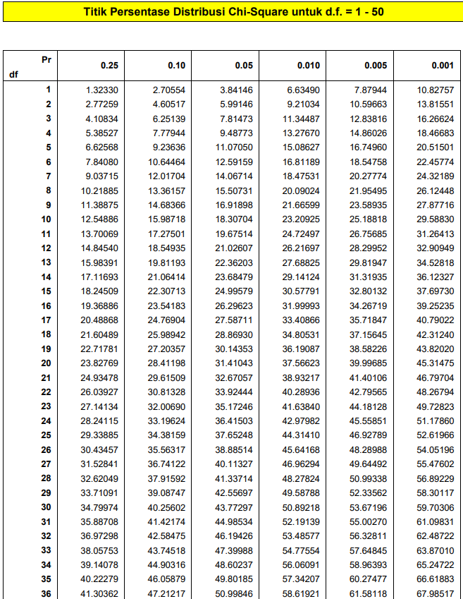

Lampiran 11
Daftar F Tabel
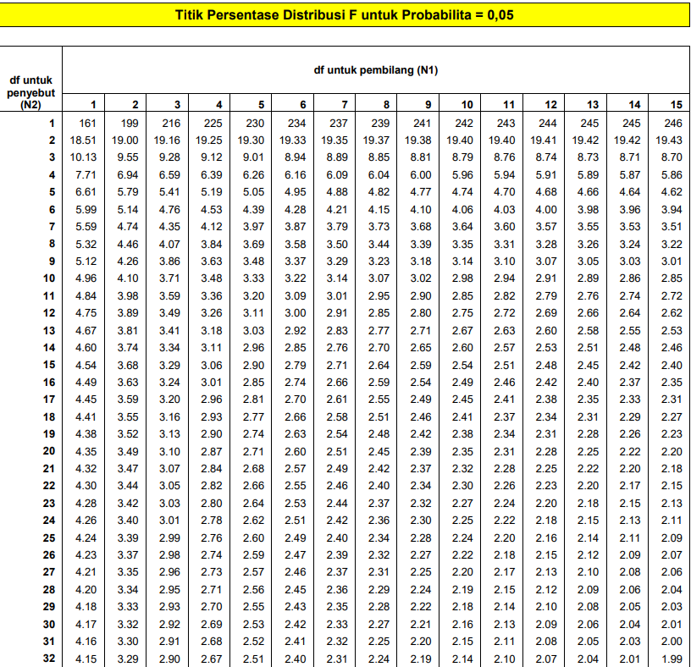

Lampiran 12
Daftar t Tabel
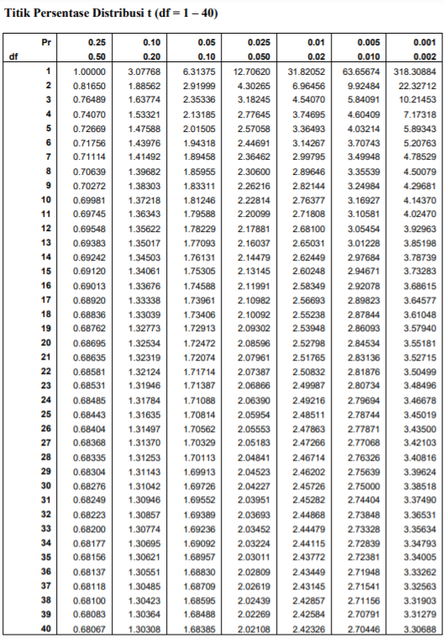

Lampiran 13
Data Keuangan yang Digunakan
NO | Kode Emiten | Tahun | Aktiva Lancar | Utang Lancar | Penjualan Bersih | Harga Pokok Penjualan | Total Utang | Ekuitas | Piutang Usaha
1 | ADRO | 2019 | 29.766.808 | 17.389.535 | 48.773.529 | 35.165.079 | 45.621.181 | 55.750.781 | 4.378.051
 |  | 2020 | 25.186.398 | 16.652.905 | 36.869.277 | 28.480.754 | 35.342.197 | 57.938.480 | 3.308.013
2 | AKRA | 2019 | 10.777.639 | 8.712.526 | 21.702.638 | 19.810.516 | 11.342.185 | 10.066.861 | 5.068.711
 |  | 2020 | 8.042.419 | 5.102.110 | 17.715.928 | 15.668.008 | 8.127.217 | 10.556.356 | 3.077.141
3 | ANTM | 2019 | 7.665.239 | 5.293.238 | 32.718.543 | 28.271.386 | 12.061.489 | 18.133.418 | 1.002.335
 |  | 2020 | 9.150.514 | 7.553.261 | 27.372.461 | 22.896.684 | 12.690.064 | 19.039.449 | 1.344.196
4 | BRPT | 2019 | 25.791.300 | 15.598.299 | 33.893.990 | 25.719.096 | 62.450.868 | 38.878.925 | 3.679.973
 |  | 2020 | 29.914.367 | 15.992.751 | 33.950.503 | 25.464.993 | 68.829.820 | 42.921.728 | 3.277.192
5 | BTPS | 2019 | 14.908.885 | 2.439.054 | 4.457.352 | 2.070.443 | 2.439.054 | 5.393.320 | 8.767.346
 |  | 2020 | 15.786.265 | 2.632.890 | 4.037.474 | 2.442.216 | 2.632.890 | 5.878.749 | 8.752.549
6 | CPIN | 2019 | 12.995.504 | 5.120.390 | 42.501.146 | 34.525.979 | 8.213.550 | 20.895.858 | 2.023.943
 |  | 2020 | 13.531.817 | 5.356.453 | 42.518.782 | 34.263.799 | 7.809.608 | 23.249.683 | 1.841.008
7 | EXCL | 2019 | 7.145.648 | 21.292.684 | 25.132.628 | 712.579 | 43.603.276 | 19.121.966 | 662.944
 |  | 2020 | 7.571.123 | 18.857.026 | 26.009.095 | 371.598 | 48.607.431 | 19.137.366 | 450.362
8 | ICBP | 2019 | 16.624.925 | 6.556.359 | 42.296.703 | 27.892.690 | 12.038.210 | 26.671.104 | 4.049.290
 |  | 2020 | 20.716.223 | 9.176.164 | 46.641.048 | 29.416.673 | 53.270.272 | 50.318.053 | 5.273.416
9 | INCO | 2019 | 8.299.920 | 1.926.476 | 11.032.625 | 9.372.269 | 3.964.277 | 27.393.405 | 1.513.718
 |  | 2020 | 10.122.913 | 2.337.527 | 11.123.201 | 9.314.109 | 4.280.157 | 29.386.543 | 873.282
10 | INDF | 2019 | 31.403.445 | 24.686.862 | 76.592.955 | 53.876.594 | 41.996.071 | 54.202.488 | 5.406.033
 |  | 2020 | 38.418.238 | 27.975.875 | 81.731.469 | 54.979.425 | 83.998.472 | 79.138.044 | 6.429.130
11 | INKP | 2019 | 59.462.074 | 25.859.583 | 45.472.243 | 33.109.360 | 63.434.830 | 56.512.091 | 16.485.946
 |  | 2020 | 63.148.470 | 27.968.086 | 43.431.850 | 30.883.777 | 61.767.350 | 61.810.999 | 18.826.510
12 | INTP | 2019 | 12.829.494 | 3.907.492 | 15.939.348 | 10.439.031 | 4.627.488 | 23.080.261 | 2.984.151
 |  | 2020 | 12.299.306 | 4.215.956 | 14.184.322 | 9.070.770 | 5.168.424 | 22.176.248 | 2.584.652
13 | JPFA | 2019 | 12.873.148 | 7.741.958 | 38.872.084 | 31.000.234 | 14.754.081 | 11.896.814 | 2.188.589
 |  | 2020 | 11.745.138 | 6.007.679 | 36.964.948 | 29.535.739 | 14.539.790 | 1.141.197 | 1.880.016
14 | KAEF | 2019 | 7.344.787 | 7.392.140 | 9.400.535 | 5.897.248 | 10.939.950 | 7.412.927 | 2.116.727
 |  | 2020 | 6.093.104 | 6.786.942 | 10.006.173 | 6.349.042 | 10.457.145 | 7.105.672 | 1.526.705
15 | KLBF | 2019 | 11.222.491 | 2.577.109 | 22.633.476 | 12.390.009 | 3.559.144 | 16.705.582 | 3.572.855
 |  | 2020 | 13.075.332 | 3.176.726 | 23.112.655 | 12.866.332 | 4.288.218 | 18.276.082 | 3.477.221
16 | MDKA | 2019 | 2.888.749 | 3.584.400 | 5.671.972 | 3.478.972 | 6.024.241 | 7.396.039 | 3.312
 |  | 2020 | 2.898.945 | 2.795.803 | 4.681.467 | 3.021.571 | 5.322.899 | 8.198.229 | 29.866
17 | MIKA | 2019 | 2.475.230 | 430.760 | 3.205.021 | 1.670.647 | 783.434 | 4.792.651 | 474.659
 |  | 2020 | 3.103.602.760 | 568.431.636 | 3.419.342.747 | 1.727.305.153 | 855.187.376 | 5.517.092.084 | 645.688.773
18 | MNCN | 2019 | 7.636.544 | 2.139.487 | 8.353.365 | 3.030.488 | 5.310.928 | 12.525.502 | 2.916.877
 |  | 2020 | 8.315.808 | 2.159.171 | 7.956.238 | 3.050.672 | 4.461.328 | 14.461.907 | 2.935.363
19 | PGAS | 2019 | 31.103.218.100 | 15.848.381.178 | 54.297.709.086 | 36.981.987.685 | 58.398.828.376 | 45.629.516.829 | 7.188.300.415
 |  | 2020 | 29.174.154.257 | 17.208.994.362 | 41.970.122.647 | 29.542.621.564 | 66.594.973.969 | 42.986.858.146 | 6.873.914.362
20 | PTBA | 2019 | 11.679.884 | 4.691.251 | 21.787.564 | 14.176.060 | 7.675.226 | 18.422.826 | 2.482.837
 |  | 2020 | 8.346.356 | 3.872.457 | 17.325.192 | 12.758.932 | 7.117.559 | 16.939.196 | 1.578.867
21 | PTPP | 2019 | 38.948.536.283 | 29.768.643.810 | 23.573.191.977 | 20.257.799.872 | 41.118.567.864 | 15.011.958.323 | 4.897.831.556
 |  | 2020 | 33.924.938.551 | 27.986.826.929 | 15.831.388.462 | 13.657.930.677 | 39.465.460.560 | 14.006.990.091 | 5.210.572.023
22 | PWON | 2019 | 9.642.587 | 3.373.097 | 7.202.001 | 3.144.166 | 7.999.510 | 18.095.643 | 807.904
 |  | 2020 | 8.590.024 | 4.336.698 | 3.977.211 | 2.036.318 | 8.860.110 | 17.598.695 | 101.924
23 | SCMA | 2019 | 3.559.332 | 988.970 | 5.523.362 | 2.862.898 | 1.228.126 | 5.488.599 | 1.731.157
 |  | 2020 | 3.609.041 | 1.542.475 | 5.101.113 | 2.491.631 | 2.870.317 | 3.896.587 | 1.853.229
24 | SMGR | 2019 | 16.658.531 | 12.240.252 | 40.368.107 | 27.654.124 | 43.915.143 | 33.891.924 | 6.489.861
 |  | 2020 | 15.564.604 | 11.506.163 | 35.171.668 | 23.554.567 | 40.571.674 | 35.653.335 | 5.777.254
25 | TKIM | 2019 | 12.401.976 | 7.623.484 | 14.772.741 | 13.260.885 | 23.659.229 | 19.544.137 | 1.490.327
 |  | 2020 | 12.174.718 | 8.807.172 | 12.602.559 | 10.862.933 | 22.700.192 | 21.998.978 | 1.005.321
26 | TLKM | 2019 | 41.722.000 | 58.369.000 | 135.567.000 | 27.592.000 | 103.958.000 | 117.250.000 | 11.797.000
 |  | 2020 | 46.503.000 | 69.093.000 | 136.462.000 | 29.563.000 | 126.054.000 | 120.889.000 | 11.339.000
27 | TPIA | 2019 | 19.597.761 | 11.060.136 | 26.536.993 | 24.122.945 | 23.845.610 | 24.844.075 | 2.277.991
 |  | 2020 | 21.848.699 | 12.564.160 | 26.274.728 | 23.873.028 | 25.923.830 | 26.347.220 | 1.849.833
28 | UNTR | 2019 | 50.826.955 | 32.585.529 | 84.430.478 | 63.199.825 | 50.603.301 | 61.110.074 | 19.680.703
 |  | 2020 | 44.195.782 | 20.943.824 | 60.346.784 | 47.357.491 | 36.653.823 | 63.147.140 | 10.024.217
29 | UNVR | 2019 | 8.530.334 | 13.065.308 | 42.922.563 | 20.893.870 | 15.367.509 | 5.281.862 | 5.335.489
 |  | 2020 | 8.828.360 | 13.357.536 | 42.972.474 | 20.515.484 | 15.597.264 | 4.937.368 | 5.295.288
30 | WIKA | 2019 | 42.335.472 | 30.349.457 | 27.212.914 | 23.732.835 | 42.895.114 | 19.215.733 | 4.461.896
 |  | 2020 | 47.980.946 | 44.168.468 | 16.536.382 | 15.011.596 | 51.451.760 | 16.657.425 | 2.175.553

